**Task-2. Subnet Configuration:**

1. **Configure one subnet as a public subnet and the other as a private subnet.**
2. **Launch an EC2 instance in each subnet. The EC2 instance in the public subnet should be reachable from the Internet.**

**Steps to configure subnet, one as a public subnet and the other as a private subnet:**

1. As, we can see in the resource map of this VPC (vpc-01) the subnets (“01vpc-subnet-01” and “01vpc-subnet-02”) are associated with the “route-table-vpc01” that is connected with the internet gateway (igw-01).

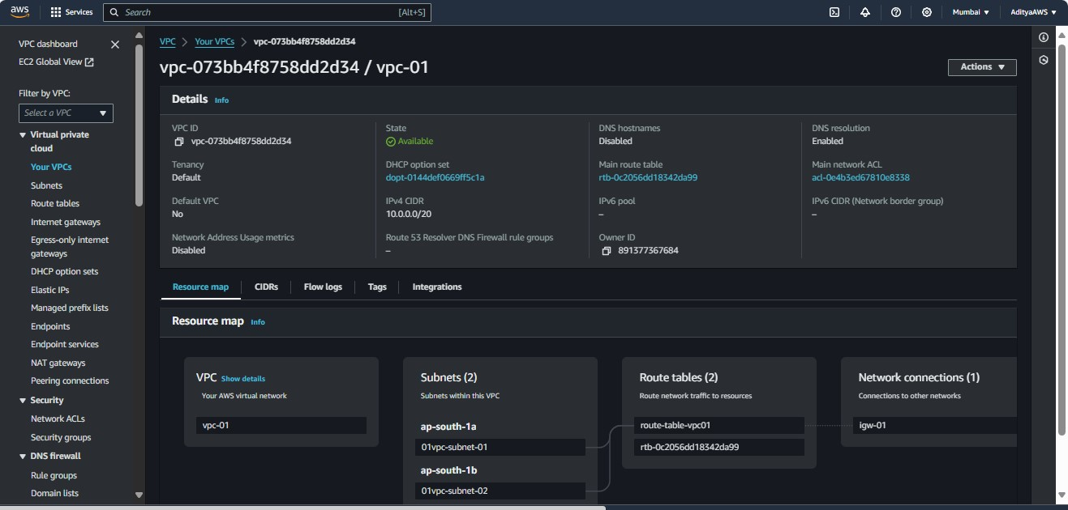

1. Now, we will edit the subnet associations of the “route-table-vpc01” and remove the “01vpc-subnet-02” from the subnet associations. Click on “Save associations”.

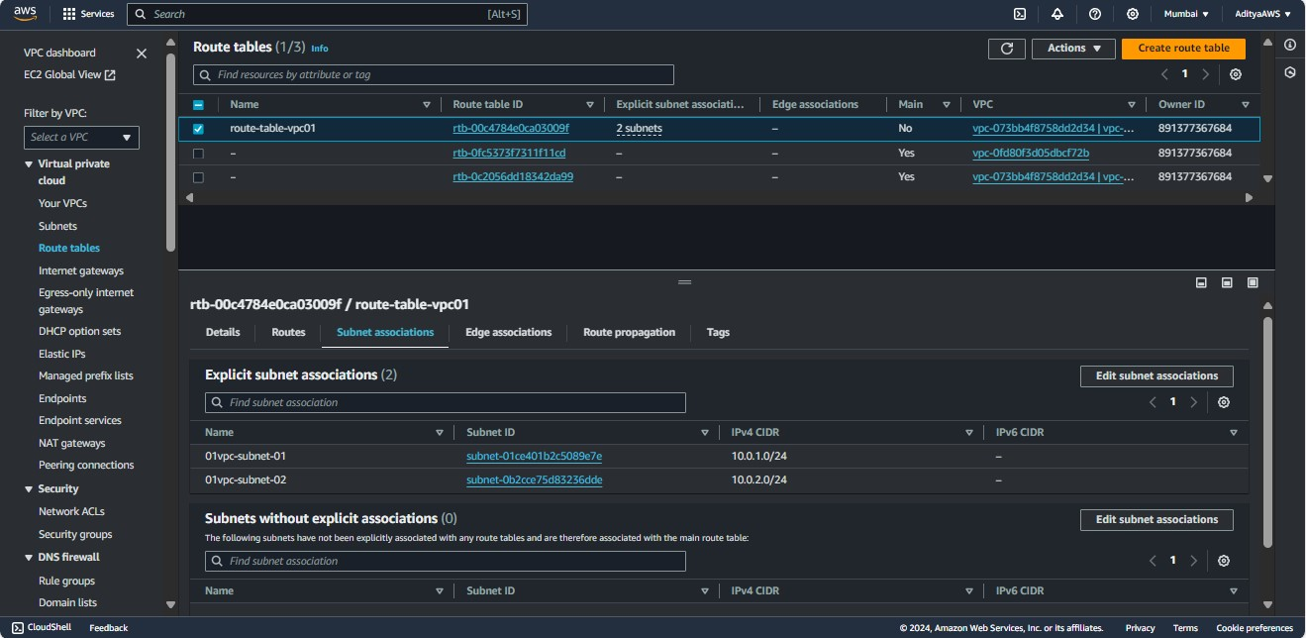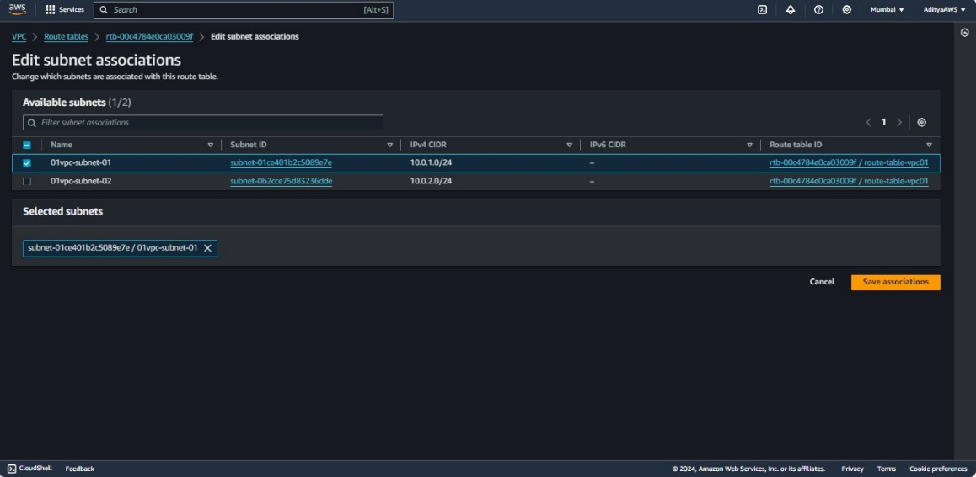

1. I have given a name (main-route-table-vpc01) to the main route table of the “vpc-01” so, that we can recognize the table. Then, select the “main-route-table-vpc01” and edit the subnet associations, add “01vpc-subnet-02” in the subnet associations.

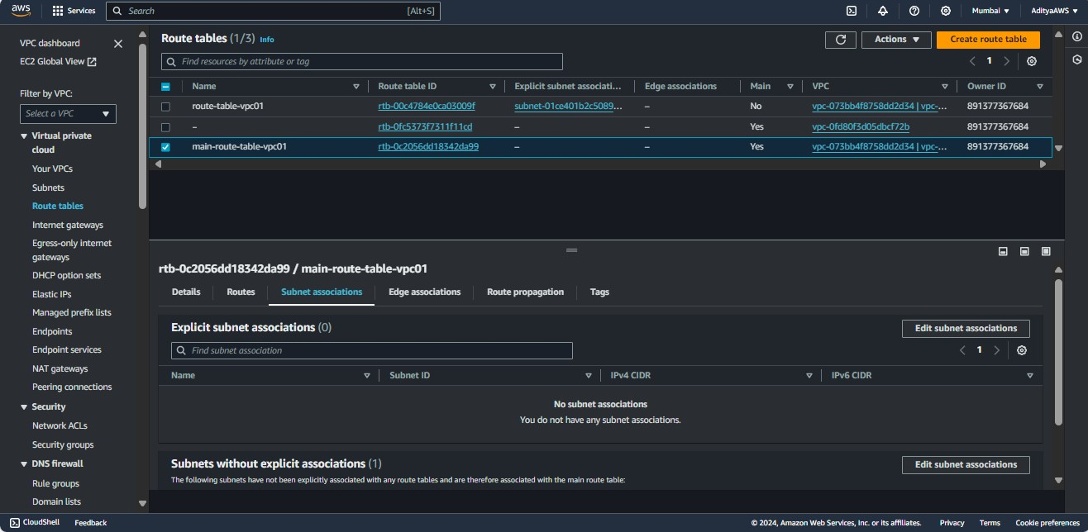

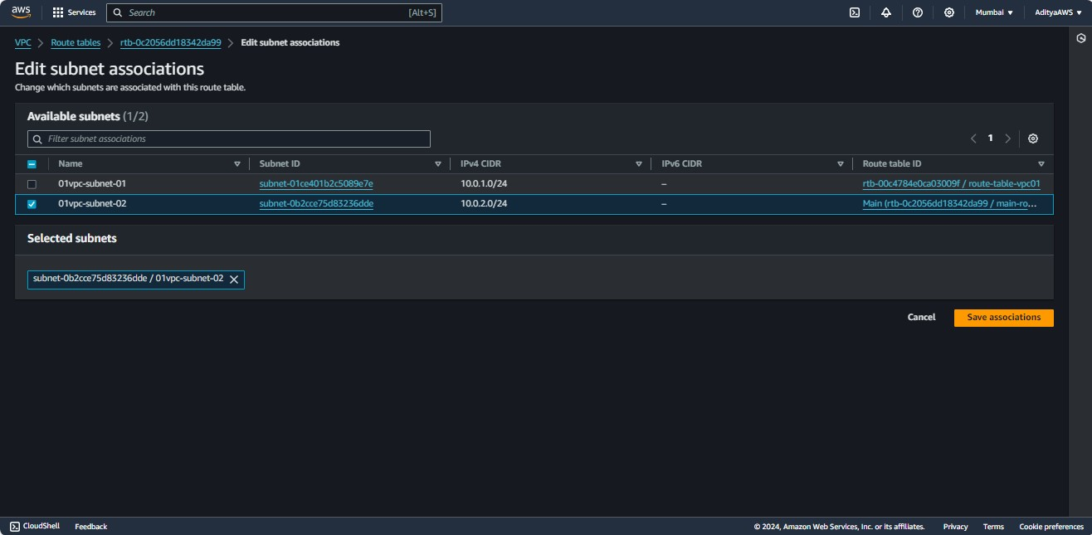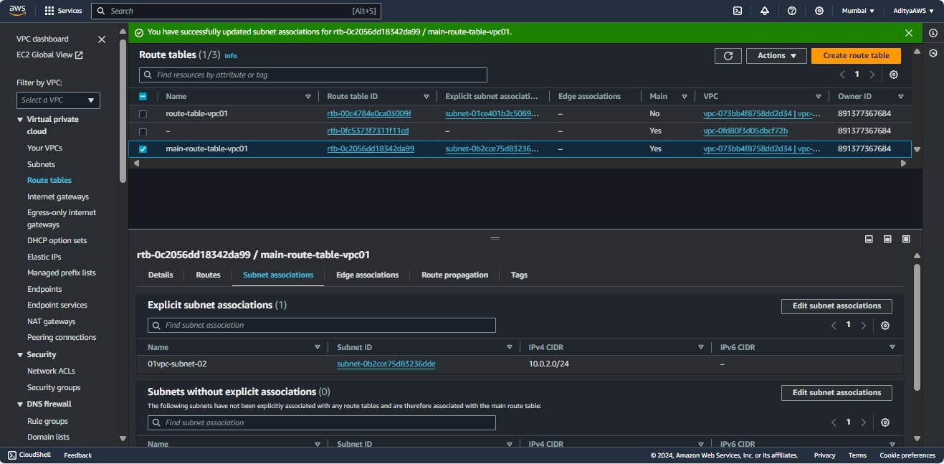

**So, now we can see in the resource map of the VPC (vpc-01) the subnet “01vpc-subnet-01” is associated with the “route-table-vpc01” which is connected with the internet gateway (igw-01) that means the subnet “01vpc-subnet-01” is public and the subnet “01vpc-subnet-02” is associated with the “main-route-table-vpc01” which is not connected with any gateway means the subnet “01vpc-subnet-02” is private now.**

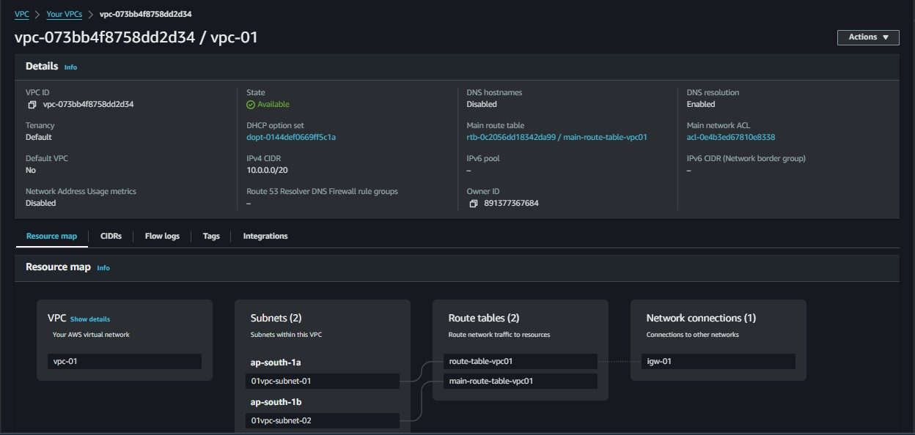

**Now, let’s launch an EC2 instance in each subnet that we have configured above:**

Launching the EC2 instance in public subnet (01vpc-subnet-01).

1. In order to launch EC2 instance go to EC2 dashboard and click on “Launch instance”. Name the instance as “server-01”.

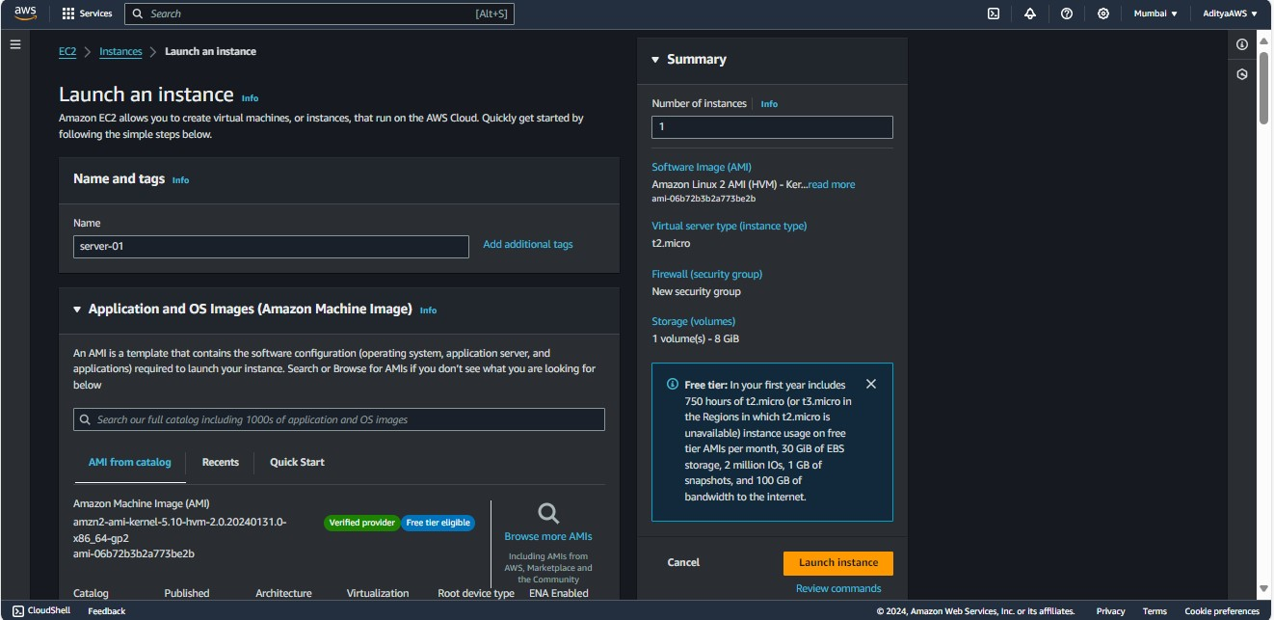

1. Now, select the AMI, instance type and Key pair (login).

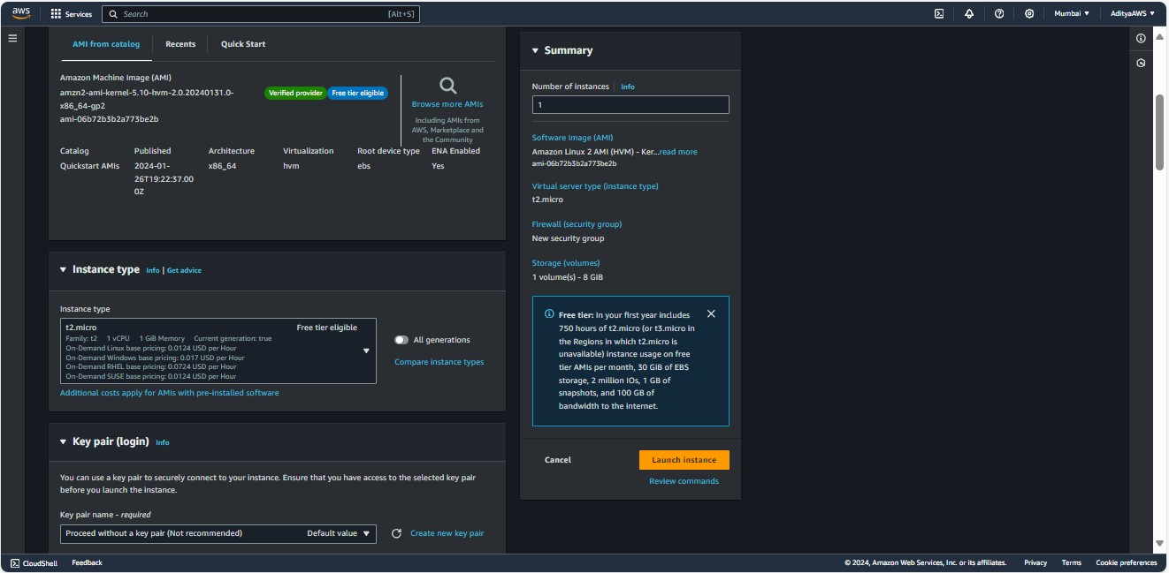

1. Edit the network settings select “vpc-01” in VPC, select “01vpc-subnet-01” (public subnet) in subnet, enable Auto-assign public IP and in Inbound Security Group Rules select “HTTP” as Type.

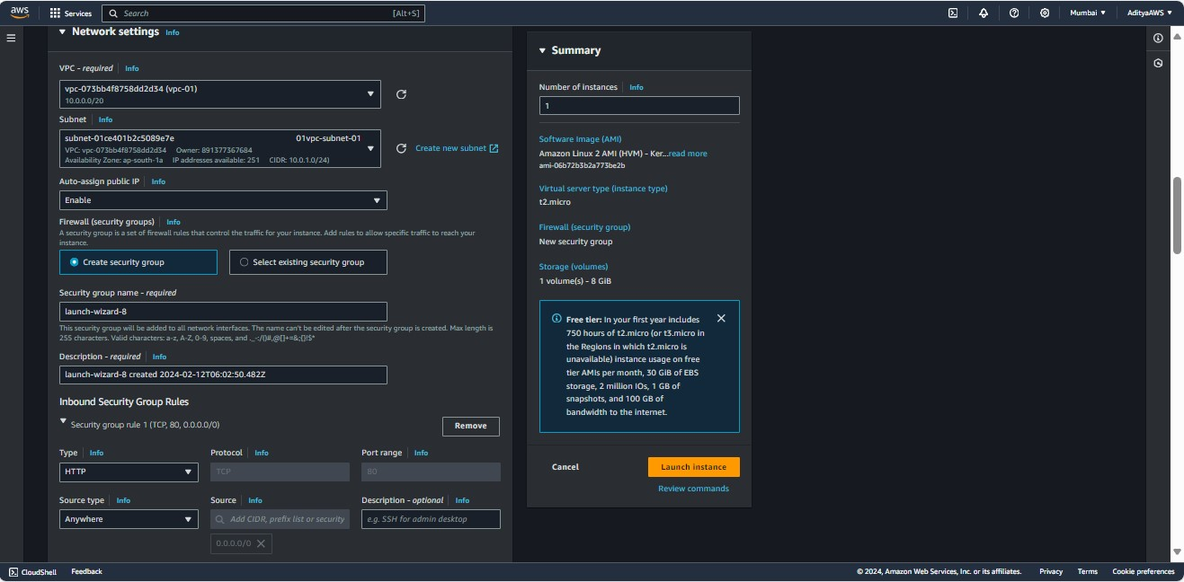

1. Click on “Advanced details” and scroll down.

Then, paste

**#!/bin/bash**

**yum udpate -y**

**yum install -y httpd**

**systemctl start httpd**

**systemctl enable httpd**

**echo "<h1>Hello, this is accessible</h1>" > /var/www/html/index.html**

in the User data. Click on “Launch instance”.

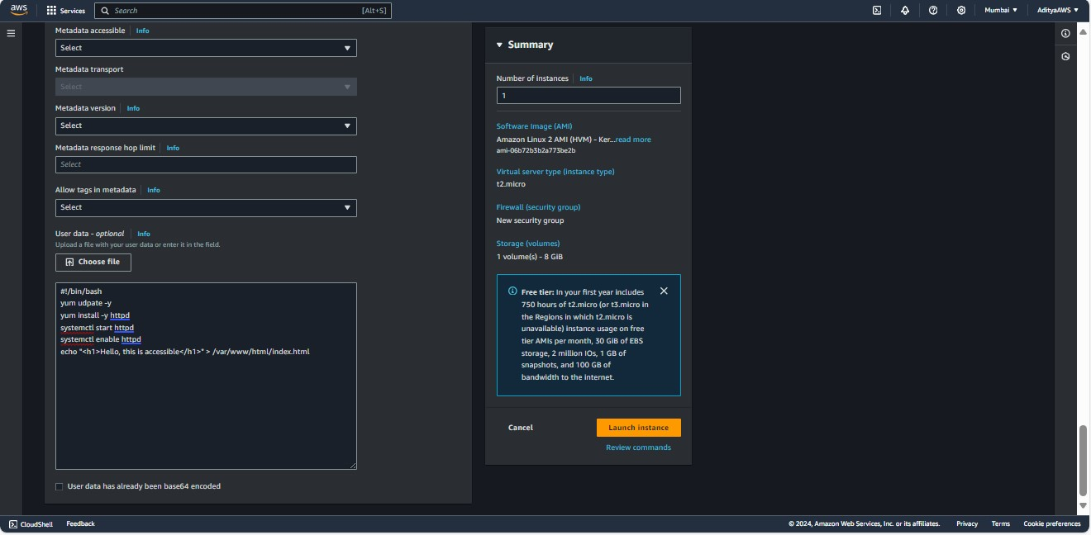

Successfully launched the EC2 instance “server-01” in public subnet.

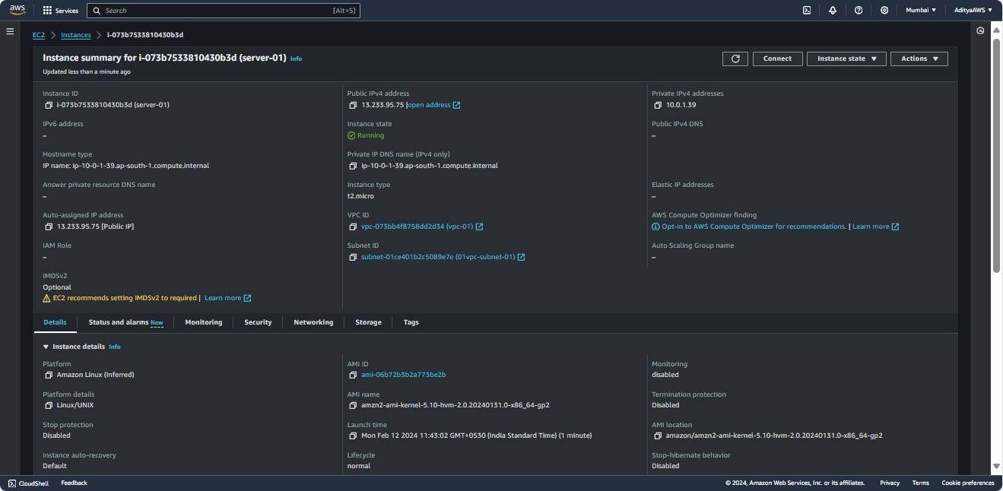

It is also reachable from the Internet.

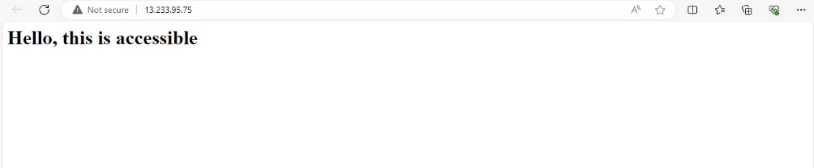

Launching the EC2 instance in private subnet (01vpc-subnet-02).

1. Again click on “Launch instance” in the EC2 dashboard. Name the instance “server-02”, select the AMI (Amazon Machine Image).

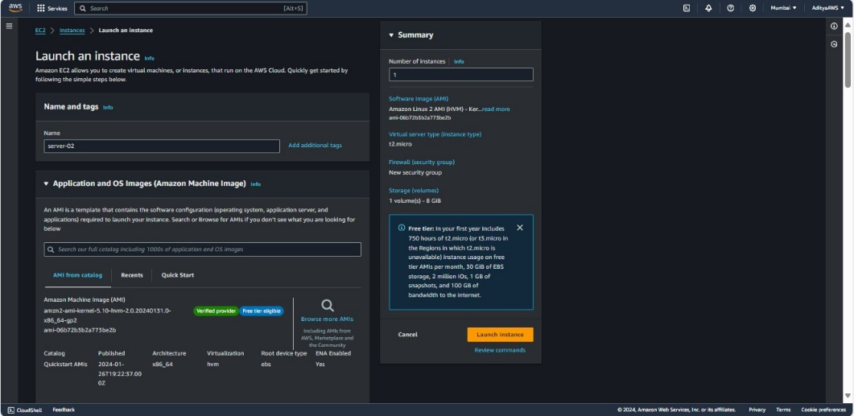

1. Select the Instance type and Key pair(login).

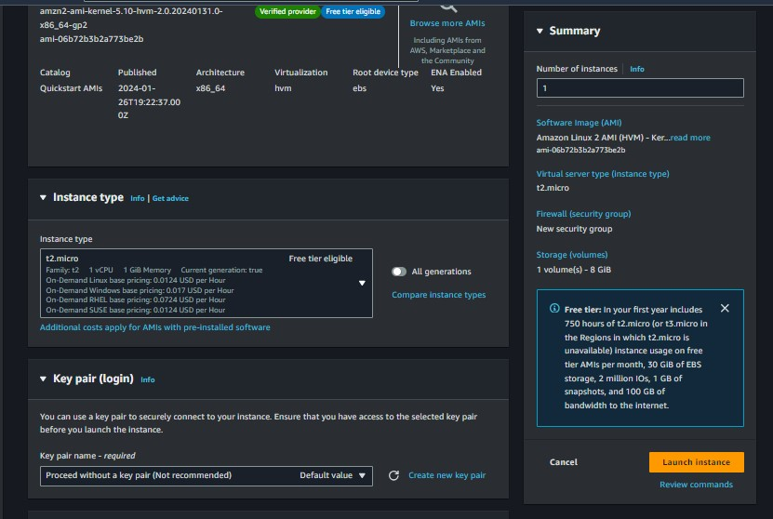

1. Now, edit the network settings choose “vpc-01” in VPC, choose “01vpc-subnet-02” (private subnet), enable the Auto-assign public IP and in Inbound Security Group Rules select “HTTP” as Type.

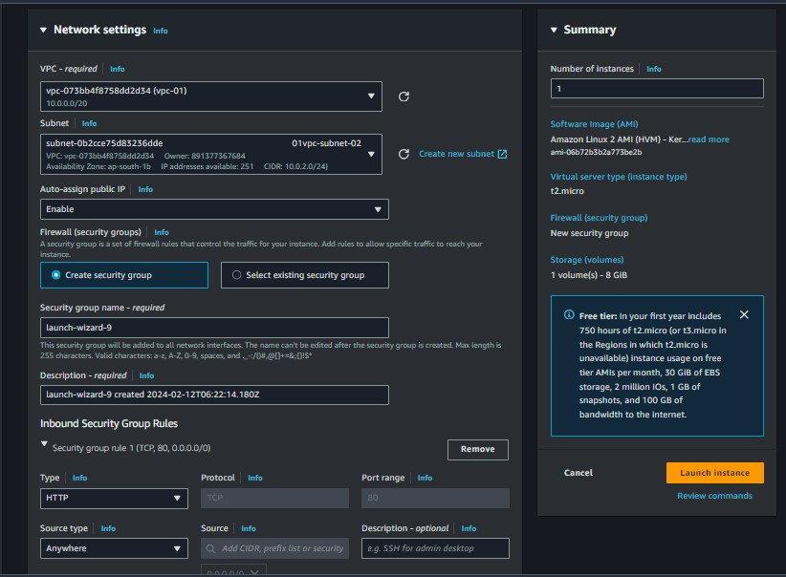

1. Click on “Advanced details” and scroll down.

Then, paste

**#!/bin/bash**

**yum udpate -y**

**yum install -y httpd**

**systemctl start httpd**

**systemctl enable httpd**

**echo "<h1></h1>" > /var/www/html/index.html**

in the User data. Click on “Launch instance”.

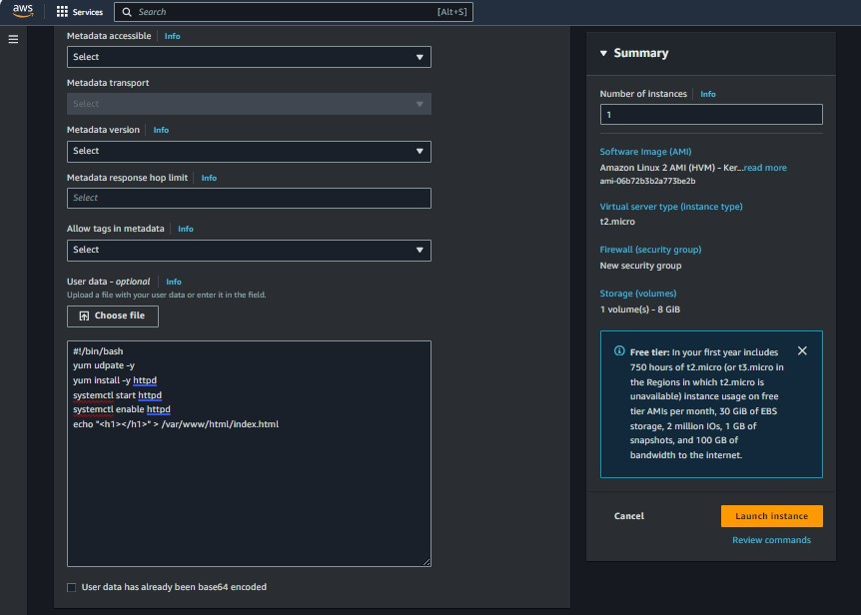

Successfully launched the EC2 instance “server-02” in private subnet.

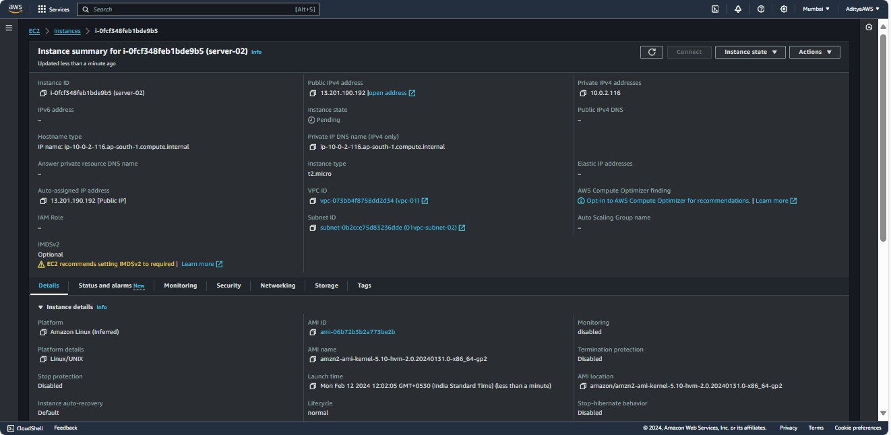

And it is not reachable from the Internet.

